**Institute of Technology Tralee**

**Ord/Hons BSc. in Computing with Specialism (Group D) - Year 1**

**Continuous Assessment #2**

**Date: 4/12/12**

**Time: 3 – 5 p.m.**

**Introduction to Programming**

**Instructions:** Attempt the following question. You should use the JCreator IDE for coding. When you are finished you must print out your code for correction.

**________________________________________________________**

**Q1. (Contains modifications to original question)**

All current registration plates for cars purchased in Ireland must conform to the following criteria. The first 2 characters of the registration plate must be digits that represent the year of purchase. The next character must be a dash symbol, the next 2 characters must be uppercase letters that represent the county in which the car was purchased (we’ll assume for simplicity here that all counties are represented by 2 characters), the next character must be another dash symbol and, finally, the last part of the registration plate must consist of digits (we will take it here that there could be any number of digits up to a maximum of 5 digits for this part of the registration plate).

Therefore, all valid registration plates will have a minimum of 7 characters and a maximum of 11 characters, depending on the number of digits in the last part of the registration plate.

Examples of valid registration plates would be 08-KY-1234 and 97-LK-98567 and examples of invalid ones would be 2008-CK-12, 89-L-234 and 67*WD*6537

You must write a Java program that processes exactly 4 registration numbers. You should use a **do-while** loop for the main loop iteration process here. As each registration number is entered it must be fully validated so that it complies with the specifics outlined in the previous paragraphs. If it fails on any of the tests, an appropriate message should be displayed to correspond with the failure. You should use a **while** loop here for the part of the validation that involves the last part of the registration number.

After the main loop has iterated 4 times, the program should display the number of valid registration numbers that were entered.

Using the test values as indicated in the screen shots below, the program should give you **exactly** the following output when it runs, including banners, blank lines, tabs etc.

Also note that there will be a few marks awarded for having a **single-line comment** and a **meaningful multi-line comment at the top of the program**

**Sample Screen Shots**

**Run 1 - The user gets asked to enter a first reg number, which is valid in this case, but all subsequent ones are invalid for various reasons, as outlined in the message given. When the main loop finishes the user gets a message telling them how many reg numbers were valid (only 1 in this case)**

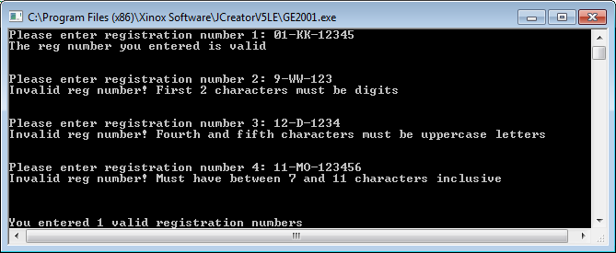

**Run 2 - The user gets asked to enter a first reg number, which is invalid in this case, as are the next 2, for various reasons. The last reg number supplied is a valid one. When the main loop finishes the user gets a message telling them how many reg numbers were valid (again only 1 in this case)**

